- Problem statement

In Japan, the highest barrier to mental health isn't finding help—it’s breaking silent endurance.
Driven by fear of societal judgment, young people mask their pain until their safe space disappears. Schools and municipalities remain completely blind to burning-out communities until a quiet struggle becomes a tragic statistic.
We catch the silent SOS before it’s too late.
Causes:
- The Disclosure Barrier: Admitting you are struggling to a parent, boss, or teacher feels overwhelming. Fear of judgment, social stigma, and the pressure to "have it all together" cause young people to internalize distress until it becomes severe.
- The Missing First Step: Most mental health solutions start at the therapy stage. There is no gentle, low-pressure bridge that helps someone translate quiet emotional overwhelm into clear self-reflection before a crisis occurs.
- Organizational Blindness: Schools and employers want to foster supportive environments, but they lack real-time visibility into overall community well-being. By the time burnout, absenteeism, or academic collapse appears, it is already too late.
Solution:
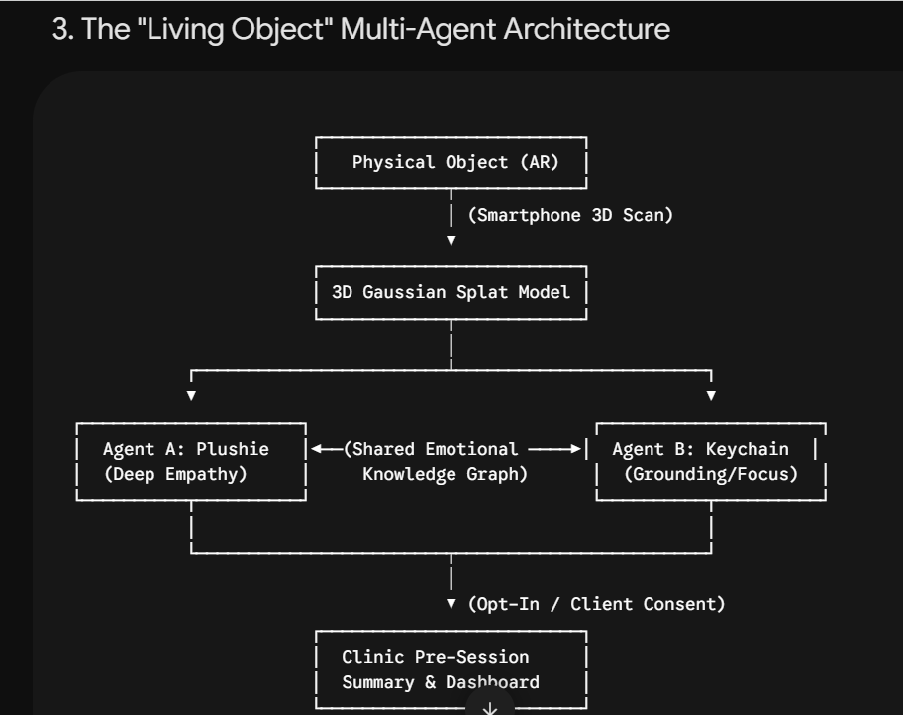
· Distinct Object Personalities: Users can scan multiple objects. Each object acts as an autonomous agent with a distinct conversational style (e.g., a desk lamp focused on study motivation vs. a plushie focused on inner-child emotional safety).
· Inter-Agent Emotional Graph: While chat histories remain siloed to protect privacy, agents share an encrypted, anonymized emotional vector state. If a user expresses severe academic stress to one object, other linked agents adjust their warmth and guidance tone seamlessly.
· Photo-to-3D Pipeline: Using cloud-based 3D Gaussian Splatting, users capture a 360-degree video on their smartphone, converting physical items into rigged, animated 3D assets in seconds.
· 4-Square Functional Matrix:
AR Daily Check-in: AI companion appears on desk via phone camera for low-friction voice/tap logs (気軽に話せる).
VR Practice Simulation: Immersive space to practice difficult conversations, such as talking to a teacher or asking for help (練習してから本番へ).
Individual Value: Low-pressure emotional expression through personal object attachment (ひとりじゃない).
Institutional Value: Anonymous class/group trends and pre-session clinical insights without individual surveillance (見守り、でも監視しない).
Competitor Differentiation:
Unlike pure apps (emol, Awarefy), Kokoro bridges physical personal belongings into digital 3D companions and connects directly into clinical/municipal workflows.
Bottom Line: "An AI dwelling in a personal belonging draws out the child's 'help me'."

